

EM 4/1 Salt Lake City, Sector V
KOLKATA – 700091
2024– 2026

MAJOR PROJECT
DATA SENSE USING AI

Under the guidance of
Mr. Rohan Mallick

SUBMITTED BY

TANDRIMA NANDY (241001271061)
SAPTARCHI DATTA (211001091001)
SUBHADIP MAITY (241001271128)
SHAWAN SUR (241001271077)
ARYA KUMAR PAL (241001271119)

SECTION - B
Techno India University

FACULTY OF MCA DEPARTMENT
CERTIFICATE OF RECOMMENDATION

This is to certify that our group have completed his Project work titled
“Minor Project On: DATA SENSE Using AI ”, under the direct supervision and guidance of Mr. “Rohan Mallick”. We are satisfied with his work, which is being presented for the partial fulfilment of the degree of Masters of Computer Application (MCA), West Bengal,
Techno India University,
Kolkata –700032.

(Mr. Rohan Mallick)
Date:

(Signature of HOD)
Date:

Techno India University
Faculty of MCA Department

Certificate of Approval*

The Foregoing Minor Project is hereby approved as a creditable study of Masters of Computer Application (MCA) and presented in a manner satisfactory to warrant its acceptance as a pre-requisite to the degree for which it has been submitted. It is statement made; opinion expressed for conclusion therein but approve this Minor Project only for the purpose for which it is submitted.

<Anuska Hazra, 22601220033>
(Signature of the Examiners)

PREFACE

Goal of the Minor Project – Data Sense AI
The primary goal of the Data Sense AI minor project is to design and develop an intelligent data analytics system that leverages Artificial Intelligence techniques to collect, process, analyze, and interpret large volumes of data in an efficient and automated manner.
This project aims to transform raw and unstructured data into meaningful insights by applying AI-based algorithms such as machine learning, data mining, and predictive analytics. The system focuses on improving decision-making accuracy, reducing manual analysis efforts, and enhancing data-driven intelligence across various domains.
Additionally, the project seeks to:
- Demonstrate the practical application of AI in modern data analytics
- Improve data processing speed and analytical accuracy
- Provide real-time insights and intelligent predictions
- Build a scalable and user-friendly analytical platform
Overall, Data Sense AI aims to bridge the gap between traditional data analysis methods and intelligent, automated analytics systems by integrating AI technologies for smarter and faster data interpretation.

Organization of the Minor Project:
Chapter 1: Describes the scope of the project. It decribes the data and controls to be used, functions etc. and what the project deals with.
Chapter 2: Deals with the concepts and problems analysis comprising of cost analysis, time analysis, term structure, software configuration management plan, quality assurance plan and risk management. Cost analysis involves estimating the cost involved in developing the project. Since, it is a major project therefore, only the efforts for developing the project and development time are estimated. Time analysis involves the requirement of time for developing different phase of the project. Team structure describes the organization of the members directly involved in this project. Software configuration management plan defines the
Chapter 3: Demonstrates theories and concepts based on which the project is developed.
Chapter 4: Represents the Software Requirements Specification (SRS) for the project which is produced for the culmination of the analysis task. The function and performance allocated to the software as a part of system engineering are refined by establishing a complete information description, a detailed functional description, a detailed functional description, a representation of system behavior, an indication of performance requirements and design constraints, appropriate validation criteria and other information regarding requirements.
Chapter 5: Describes the design of the project comprising of data design, architecture design, interface design.
Chapter 6: Deals with the coding standard that has been followed during the project so as to easy understanding and readability of the project.
Chapter 7: Result Set Analysis.
Chapter 8: Describes the testing strategies that have been used for the project to uncover the errors associated with it. To ensure that the project of good quality, tests have been conducted systematically and test cases have been designed using disciplined techniques.
Chapter 9: Describes the future scope of the project. It highlights all the possible areas that can be improved later so as to enhance performance, features and functionalities.
Chapter 10: Describes the conclusion from the project.
Chapter 11: Lists the references and Bibliography for the project

Technology Used

- Python
Python is a high-level, versatile programming language used for backend development, data analysis, and AI/ML implementations. In DataSense AI, Python handles data processing, AI logic, and integration with the frontend.

2. HTML (HyperText Markup Language)
HTML is used to structure the content of web pages. It defines headings, paragraphs, tables, forms, and other elements that users see in the browser.

3. CSS (Cascading Style Sheets)
CSS is used to style and design HTML content, including colors, fonts, layouts, and responsive design, making the application visually appealing.

4. Pandas
Pandas is a Python library for data manipulation and analysis. It allows handling large datasets, performing calculations, and preparing data for visualization or AI models.

5. Matplotlib
Matplotlib is a Python library used for data visualization. It helps create graphs, charts, and plots to represent data insights in a visual format.

6. Flask for backend.

ACKNOWLEDGEMENT

We take this opportunity to express our sincere gratitude to all those who helped us in various capacities in undertaking this project and devising this report.
We are privileged to express our sense of gratitude to our respected teachers Mr. Rohan Mallick whose unparalleled knowledge and judgment helped us throughout the project in many ways along with hi know-how and also providing us with some important information regarding the development of the project was an immense support in completing the project.
We take this opportunity to thank our friends and team members for their cooperation and compliance.

DATA SENSE AI

Chapter No. Topic SL No.
 | Technology Used
1 | Scope of the project
2 | Concepts and problems analysis  - Cost Analysis (use COCOMO MODEL / Function  point)  - Software Configuration Management
3 | Theoretical Background
4 | Software Requirement Specification  - Design Constrains  - External Interface Designs  - Data Designs  - ER Diagram  - DFD Diagram  - Use case Diagram  - System Security Measures
5 | Design/Solution/Methodology  - Data design (give flowchart diagram)  - Interface design (give snap shots) Procedural Design
6 | Coding Standard Followed and Assumptions
7 | Result Set Analysis
8 | Testing
9 | Future Scope of the Project
10 | Conclusion
11 | Reference and Bibliography
12 | Appendix

Chapter 1: Introduction
Artificial Intelligence has transformed the way data is processed, analyzed, and interpreted in modern applications.
DataSense AI is an AI-powered web-based data analysis platform designed to automate data understanding, visualization, and insight generation.
This project aims to simplify complex data analytics tasks for students, researchers, and non-technical users.
The system supports CSV, Excel, and PDF files and provides instant statistical analysis and visual insights.
In today's data-driven world, such tools are essential for faster and more accurate decision-making.
Chapter 2: Problem Statement
Organizations and students often struggle with manual data analysis processes.
Traditional tools require technical expertise in programming and statistics.
There is a lack of integrated platforms that combine data upload, cleaning, analysis, visualization, and AI insights.
DataSense AI addresses these challenges by providing an intelligent, user-friendly solution.
The system reduces time, effort, and errors in data analysis workflows.
Chapter 3: Objectives of the Project
To design and develop an AI-powered data analysis web application.
To support multiple data formats such as CSV, Excel, and PDF.
To perform automated statistical analysis and visualization.
To detect missing values, duplicates, and outliers in datasets.
To provide a scalable and modular system architecture.
Chapter 4: Scope of the Project
The project focuses on structured datasets commonly used in analytics.
It is suitable for educational, research, and small business use cases.
The system is web-based and accessible through modern browsers.
Future scope includes predictive analytics and natural language querying.
The project demonstrates real-world application of AI and data science concepts.
Chapter 5: Literature Review
Various data analysis tools such as Excel, Tableau, and Power BI exist.
However, these tools often require manual configuration and expertise.
Recent research emphasizes AI-driven automation in data analytics.
LLMs and machine learning models are increasingly used for insight generation.
DataSense AI builds upon these concepts to deliver an integrated solution.
Chapter 6: System Architecture
The architecture of DataSense AI follows a modular client-server model.
The frontend is developed using HTML, CSS, and JavaScript.
The backend is powered by Flask (Python).
Data processing is handled using Pandas and NumPy libraries.
Visualization is implemented using Plotly for interactive charts.
Chapter 7: System Screenshots
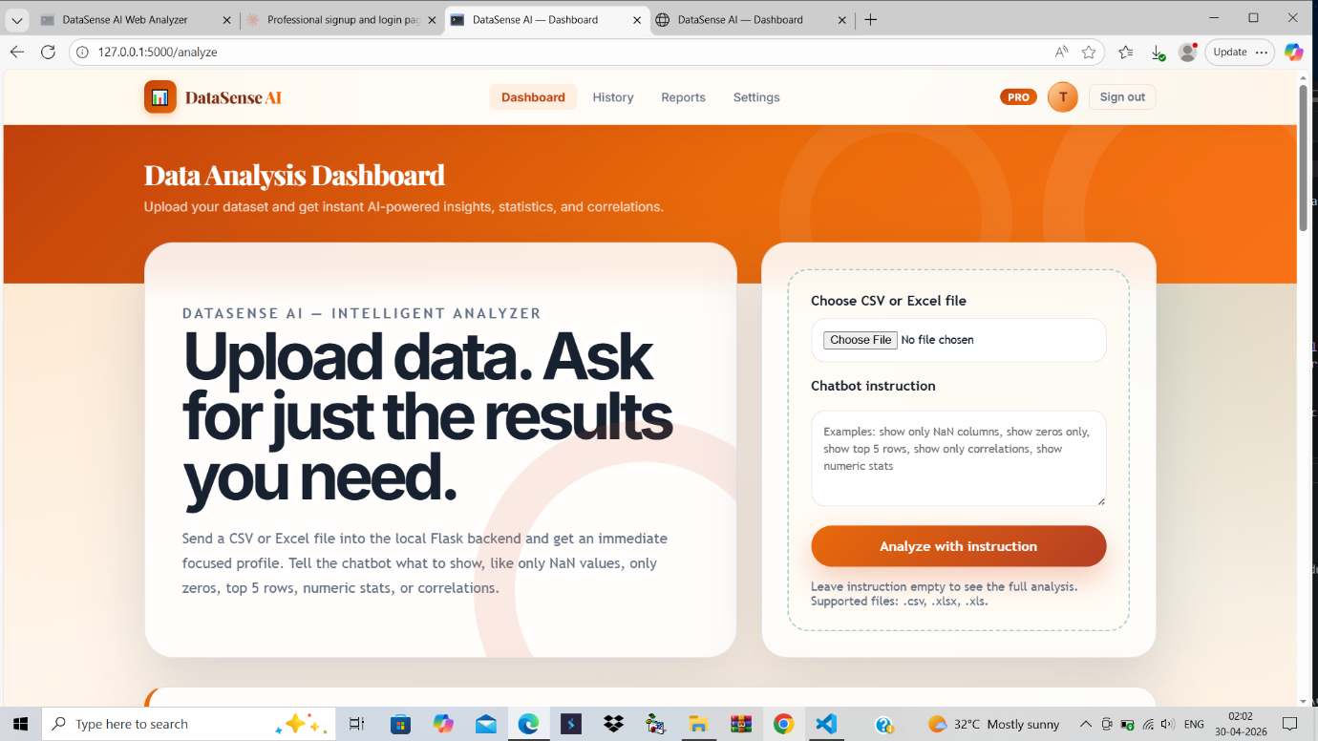

Figure: DataSense AI Interface Screenshot
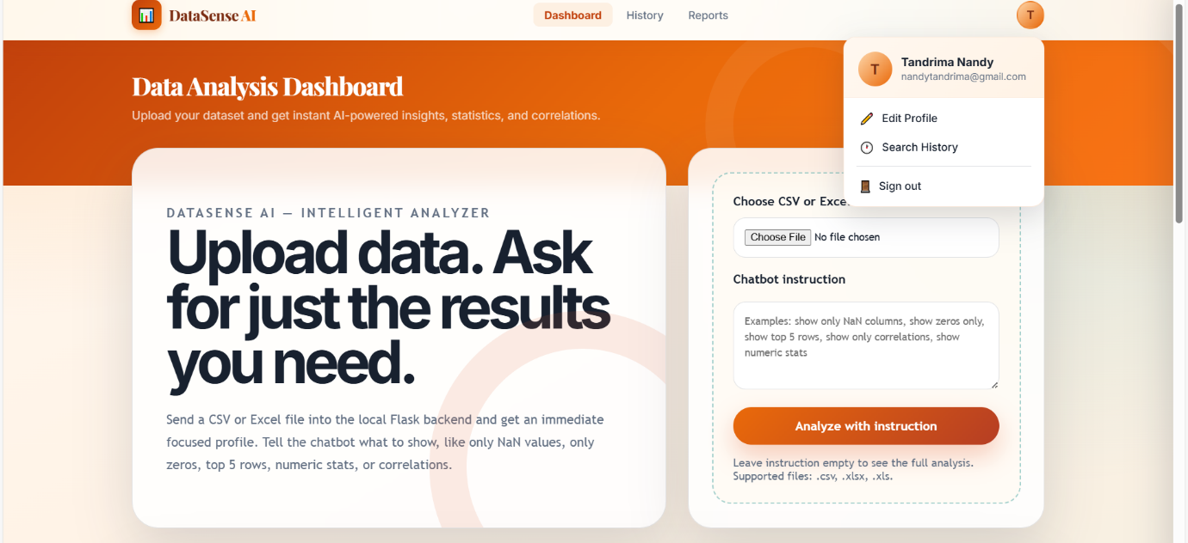

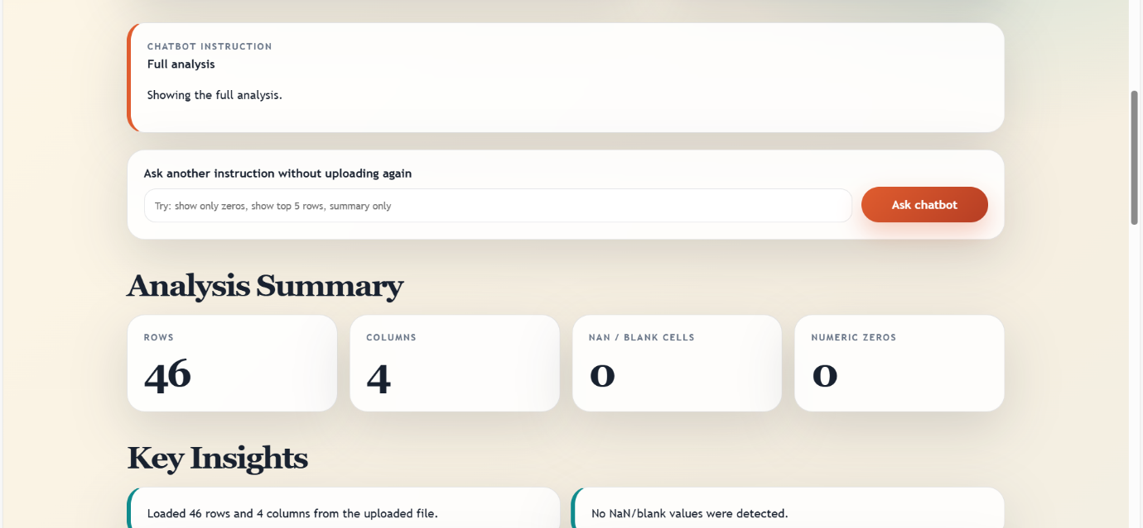

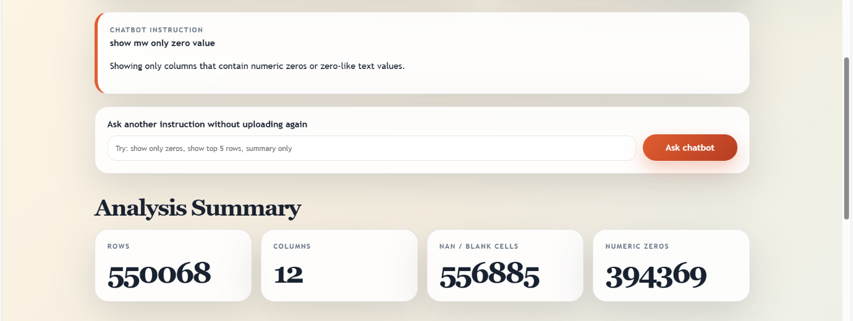
Figure: DataSense AI Interface Screenshot

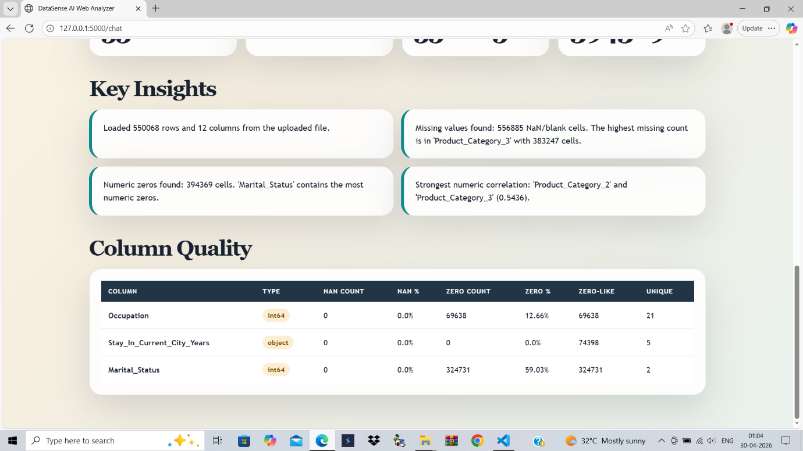
Figure: DataSense AI Interface Screenshot

Figure: DataSense AI Interface Screenshot

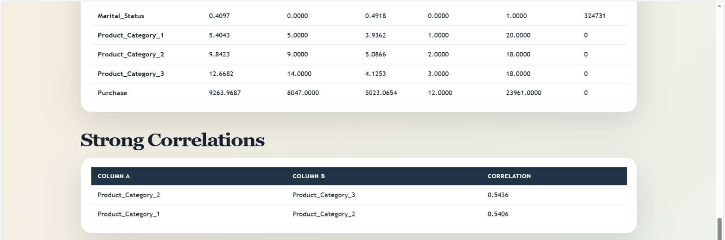

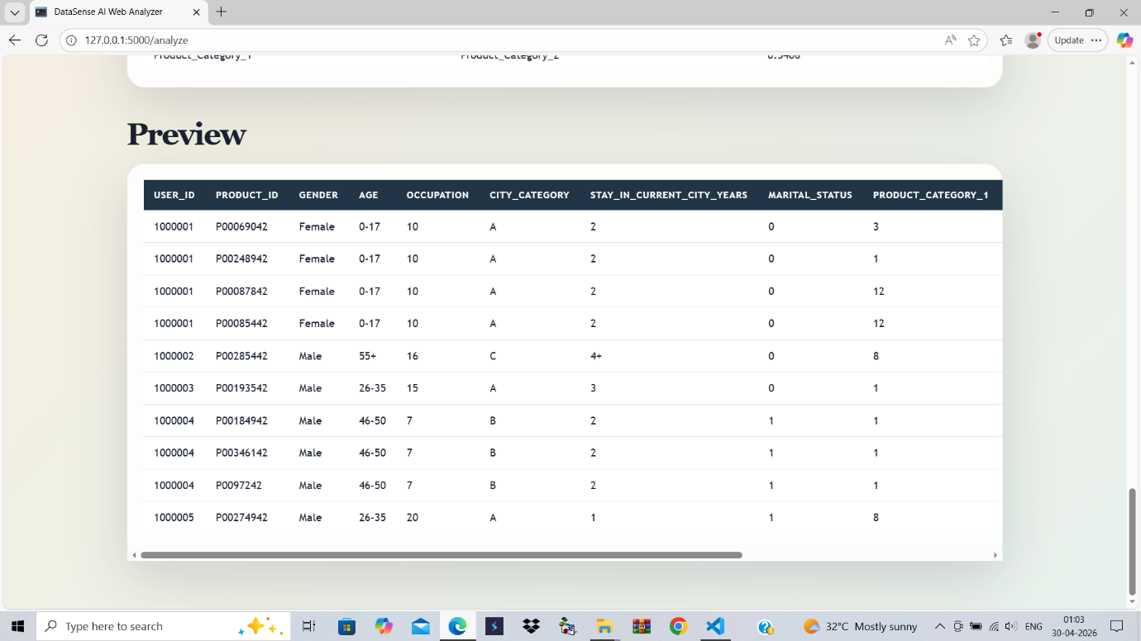
Figure: DataSense AI Interface Screenshot

Figure: DataSense AI Interface Screenshot

THE LOGIN PAGE :
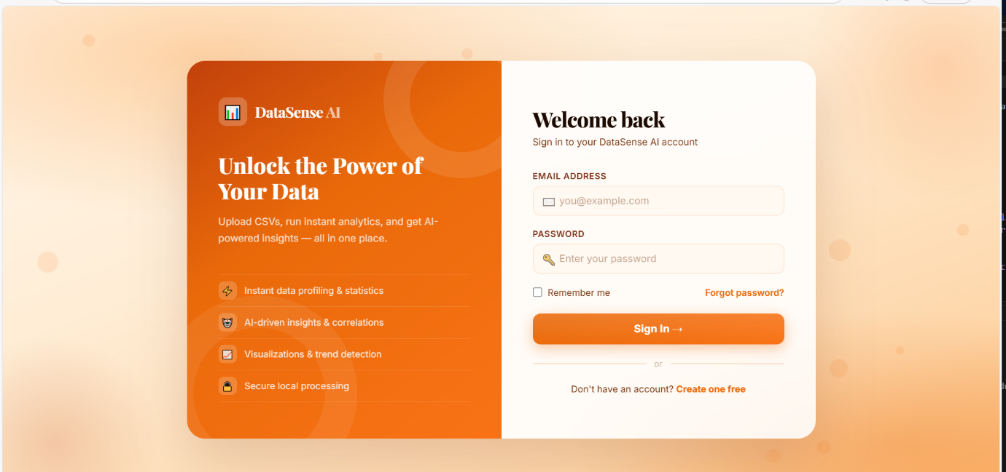

The history check page :
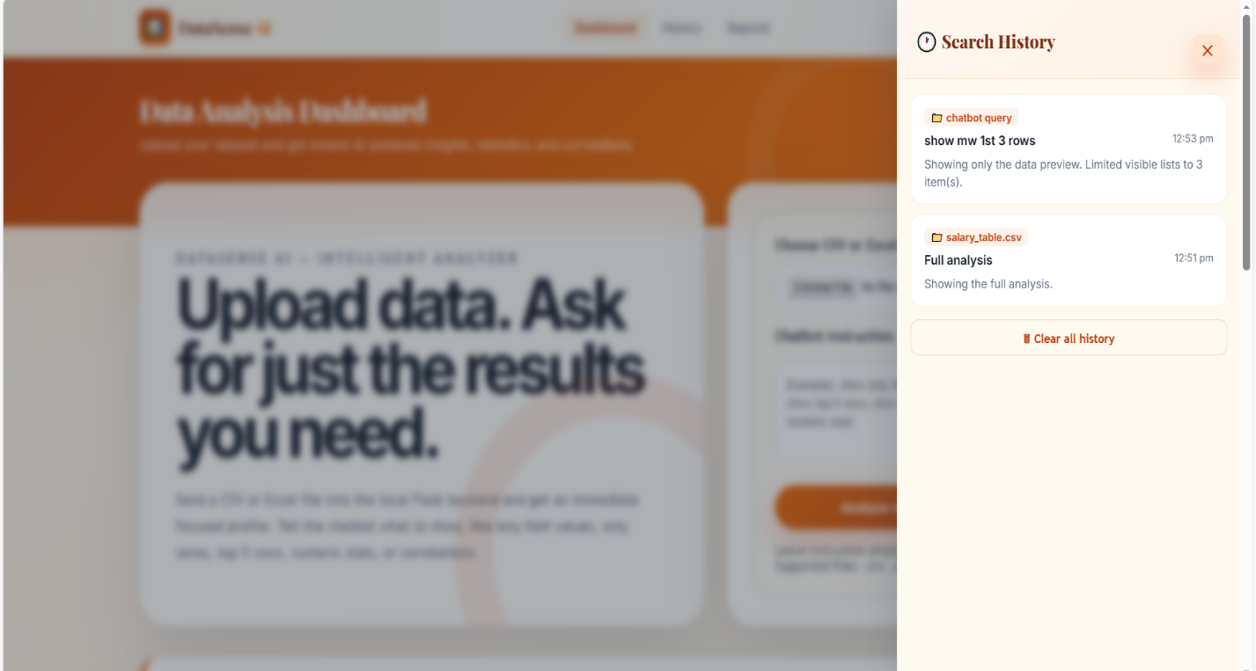

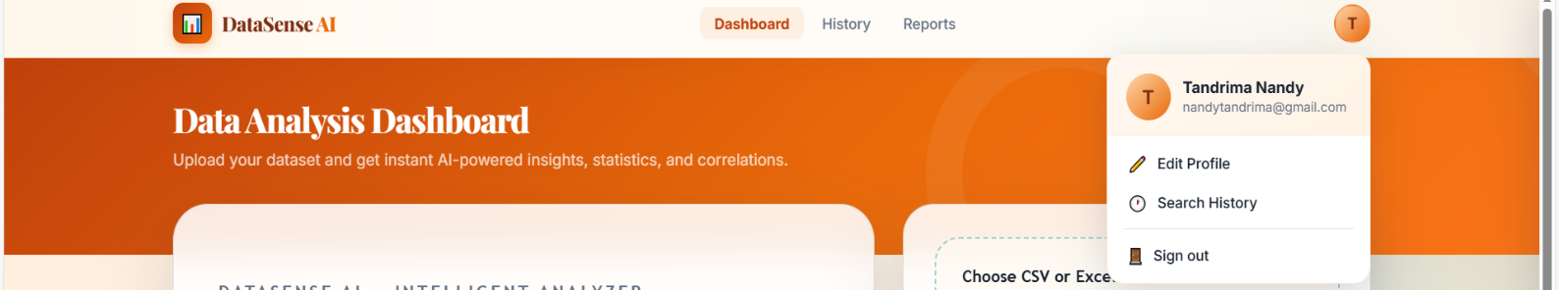

Chapter 8: Frontend Design
The frontend provides a clean and responsive user interface.
Navigation tabs include Overview, Statistical Analysis, Visualizations, and Data Preview.
Users can upload files easily using the upload panel.
The dashboard displays summary cards for quick insights.
User experience is prioritized with minimal interaction steps.

Chapter 9: DFD diagram
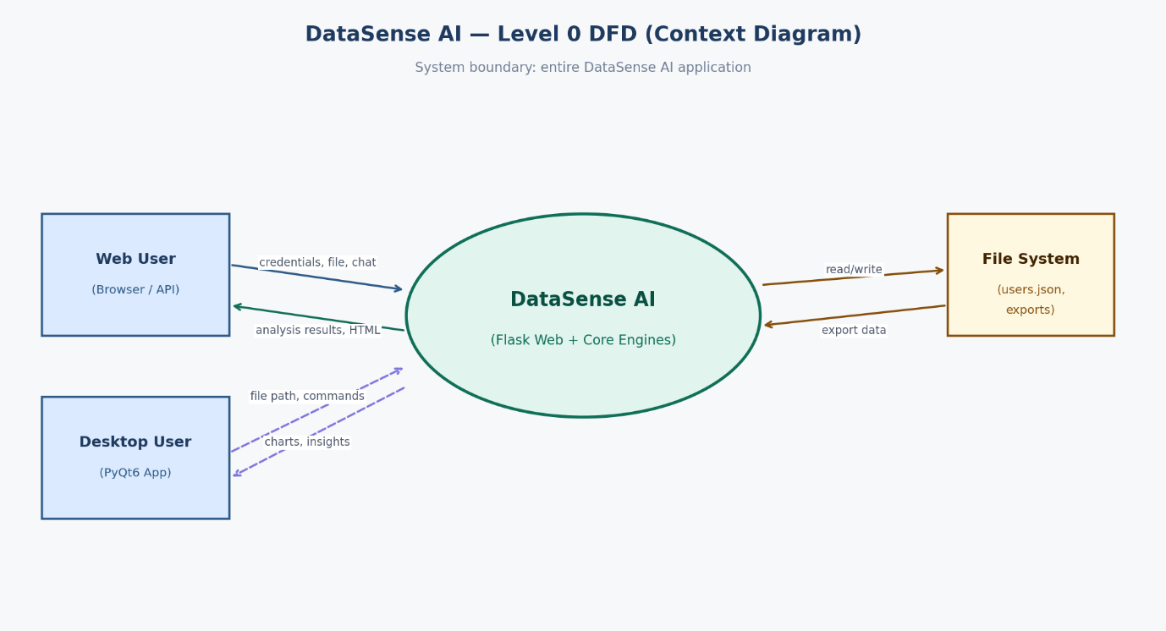

Chapter 10 : ER Diagram

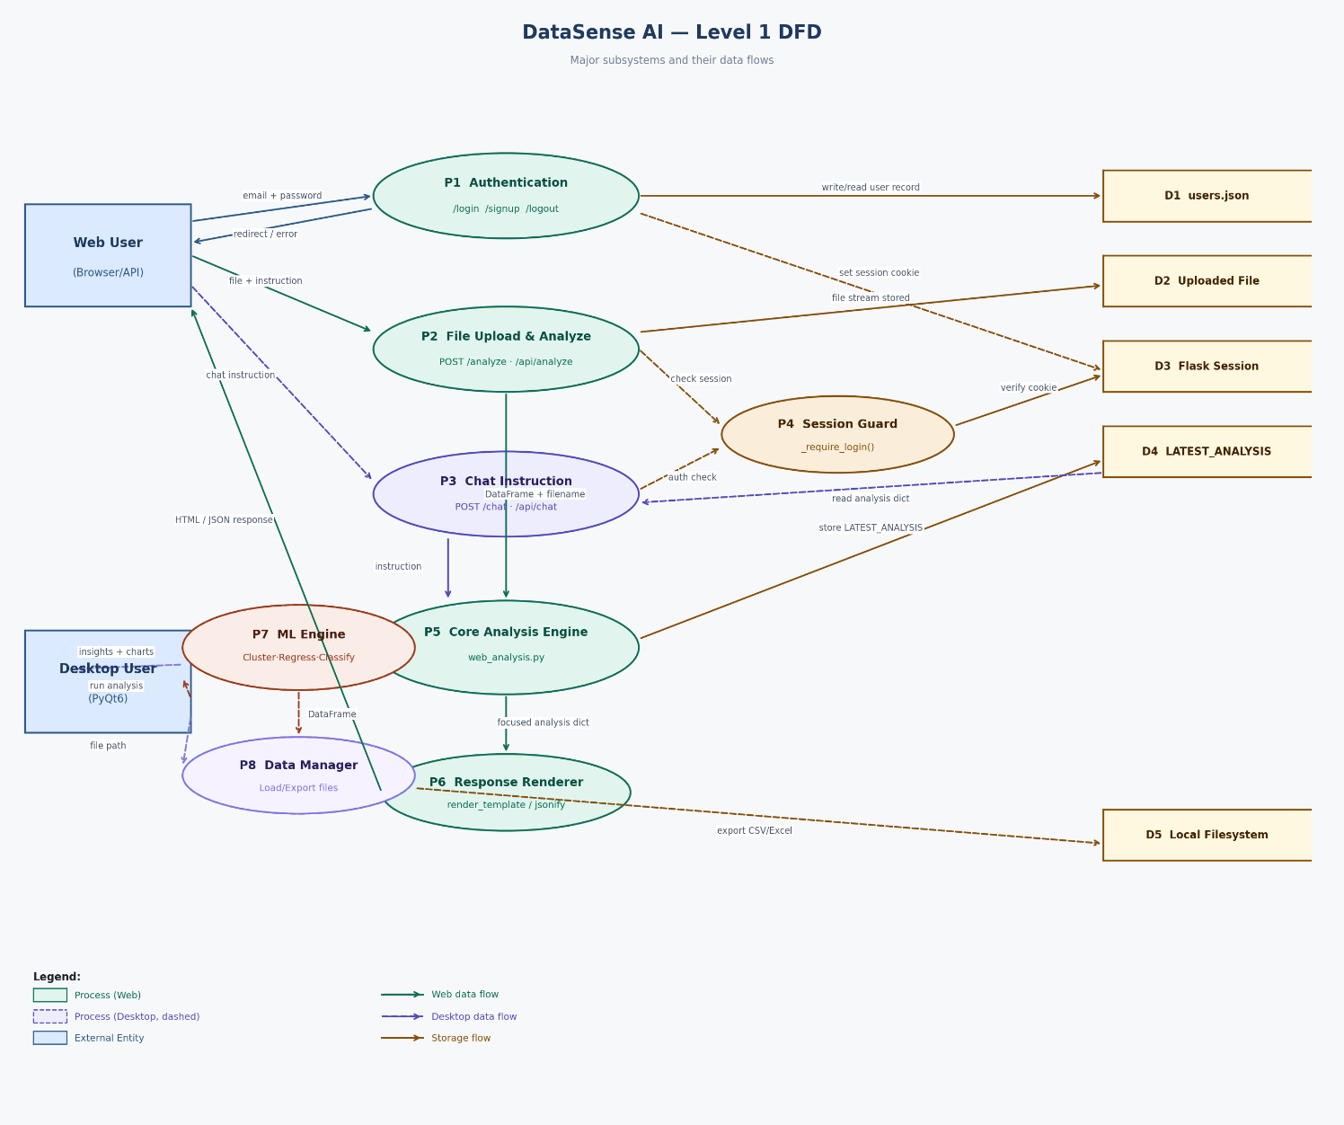

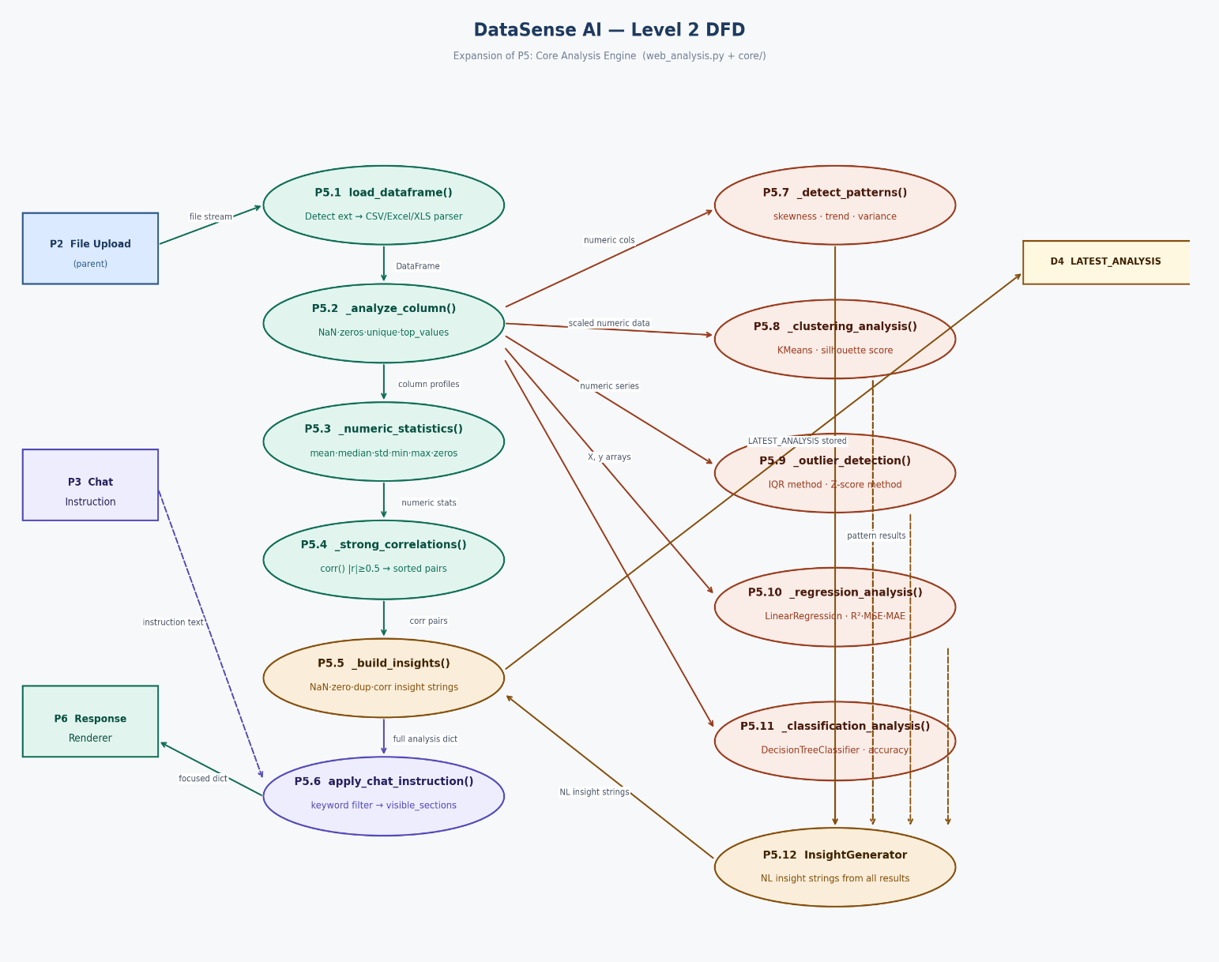

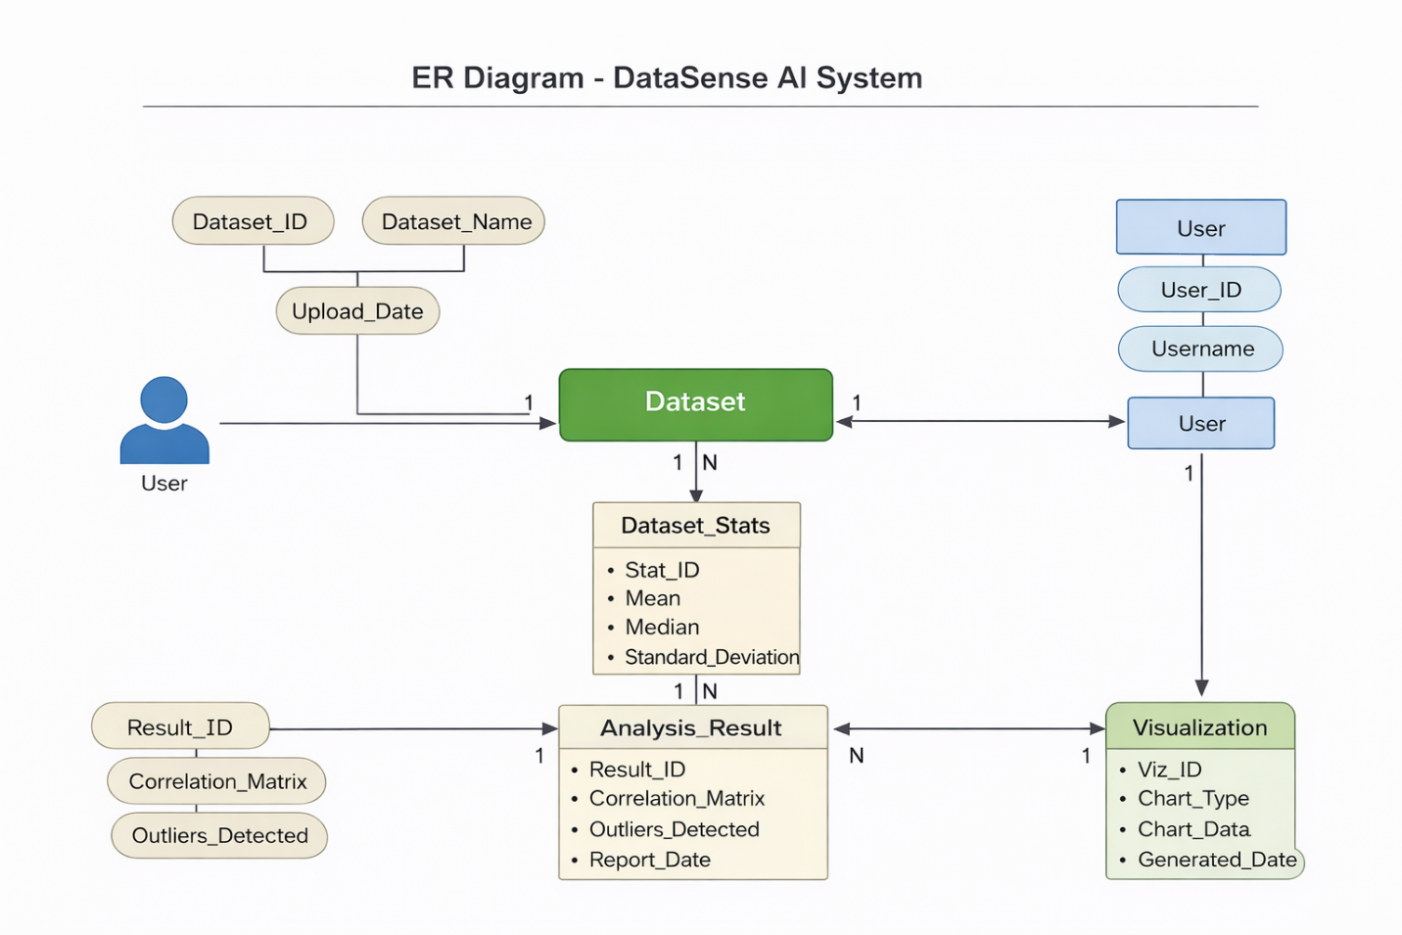
1st ER Diagram :

2nd ER Diagram :
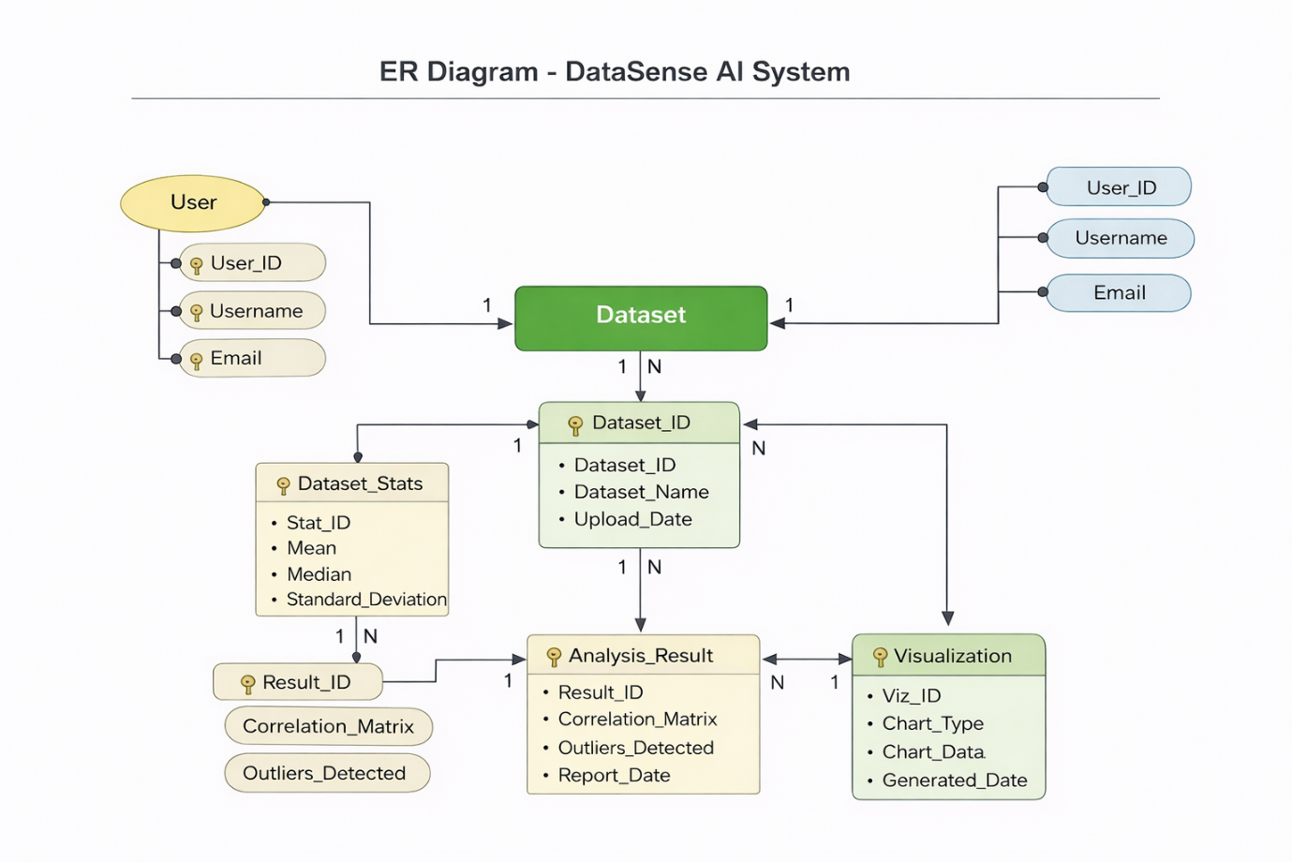

Topic about 5:
DESIGN / SOLUTION / METHODOLOGY
Overview of the Proposed Solution
The proposed system, DataSense AI, is designed to provide an intelligent, automated, and user-friendly platform for data analysis. The solution integrates artificial intelligence techniques with modern data processing tools to transform raw datasets into meaningful insights. The system follows a modular architecture where each component is responsible for a specific task such as data input, preprocessing, analysis, visualization, and result presentation. This approach ensures scalability, maintainability, and efficient performance.

1. Data Design
Data Design Description
Data design defines how data is collected, processed, stored, and transformed within the system. In DataSense AI, the primary data source is user-uploaded datasets in structured formats such as CSV or Excel files. Once the dataset is uploaded, it undergoes validation to ensure correctness and compatibility. After validation, the data is cleaned by handling missing values, removing duplicates, and normalizing numerical values where necessary.
The processed data is then passed to analytical modules that compute statistical measures, detect outliers, and generate correlations. The analyzed results are stored temporarily and presented to the user through visual dashboards and reports.

The Chatbot Features:

File upload & analysis — The chatbot accepts .csv, .xlsx, and .xls files and immediately profiles them: row/column counts, NaN cells, zeros, duplicate rows, and memory size.
Instruction-based filtering — You type plain English and the chatbot narrows the output. It recognizes keywords like "NaN", "zeros", "correlations", "stats", "summary", and "preview" and hides everything else.
Numeric statistics — Ask for "mean", "stats", or "median" to get a full stats table: mean, median, std deviation, min, max, and zero count per numeric column.
Correlation detection — Typing "show correlations" reveals all column pairs with a correlation ≥ 0.5, sorted strongest first — useful for spotting relationships in numeric data.
Data preview — Ask for "rows", "preview", or "top N rows" to see the raw data in a table, up to 10 rows by default.
Result limiting — Combine any command with a number ("top 3", "first 10 columns") to cap how many results appear. Works across all views.
Re-query without re-upload — Once a file is analyzed, the bottom chat bar lets you ask new instructions on the same dataset — no need to re-upload the file each time.
Search history — All chatbot queries are saved in the browser (localStorage) and accessible from the History side panel in the nav, showing the instruction, file name, time, and response preview.

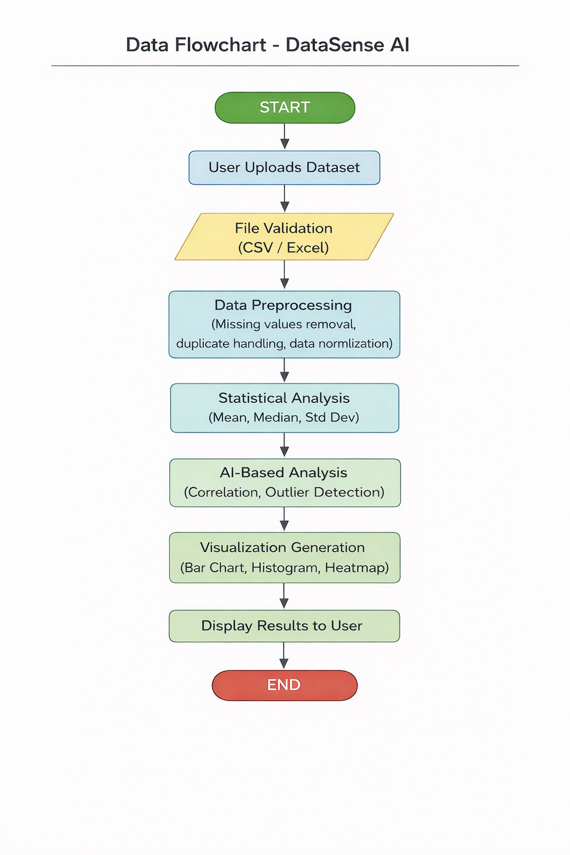

Flowchart Explanation
The data flow begins when the user uploads a dataset through the system interface. The system first validates the file format to ensure compatibility. Once validated, preprocessing operations are applied to improve data quality. The cleaned dataset is then passed through statistical and AI-based analysis modules. Finally, the system generates visual outputs and analytical insights, which are displayed on the dashboard for user interpretation.

2. Interface Design
Interface Design Description
The interface of DataSense AI is designed with simplicity and usability as primary goals. The system uses a web-based graphical user interface that allows users to interact with the system without requiring technical knowledge. The interface follows a clean layout with intuitive navigation to ensure a smooth user experience.
The frontend communicates with the backend through APIs, allowing real-time data processing and visualization updates.

Interface Screens (Snapshots Description)
(You can insert screenshots in your document under these headings)
1. Home Page / Dashboard
The dashboard serves as the main entry point of the system. It displays an overview of the application and provides an option for dataset upload. Summary cards showing dataset size, number of attributes, and missing values are also displayed.
2. Dataset Upload Screen
This screen allows users to upload CSV or Excel files. It includes validation messages to inform users about successful uploads or errors in file format.
3. Statistical Analysis Screen
The statistical analysis interface displays computed values such as mean, median, standard deviation, minimum, and maximum in a tabular format. This helps users quickly understand the basic characteristics of the dataset.
4. Visualization Screen
This section presents graphical outputs such as bar charts, histograms, and correlation heatmaps. Interactive charts enable users to visually explore patterns and trends within the data.
5. Outlier Detection Screen
The outlier detection interface highlights abnormal data points and displays the percentage of outliers present in the dataset, assisting in data quality assessment.

3. Procedural Design
Procedural Design Explanation
Procedural design explains the step-by-step working of the system from user interaction to result generation. DataSense AI follows a structured procedure to ensure accuracy and efficiency in data analysis.
Initially, the user accesses the system through a web browser and uploads a dataset. The system validates the file format and checks for inconsistencies. After successful validation, preprocessing functions are executed to clean the data. This step ensures that missing values and duplicate records do not affect analytical accuracy.
Next, statistical procedures compute essential measures such as mean, median, and standard deviation. AI-based procedures then analyze relationships between variables and detect outliers using statistical techniques. Visualization procedures convert analytical results into graphical representations, making insights easy to understand.
Finally, all results are compiled and presented to the user through the dashboard. This procedural flow ensures automation, reliability, and user convenience.

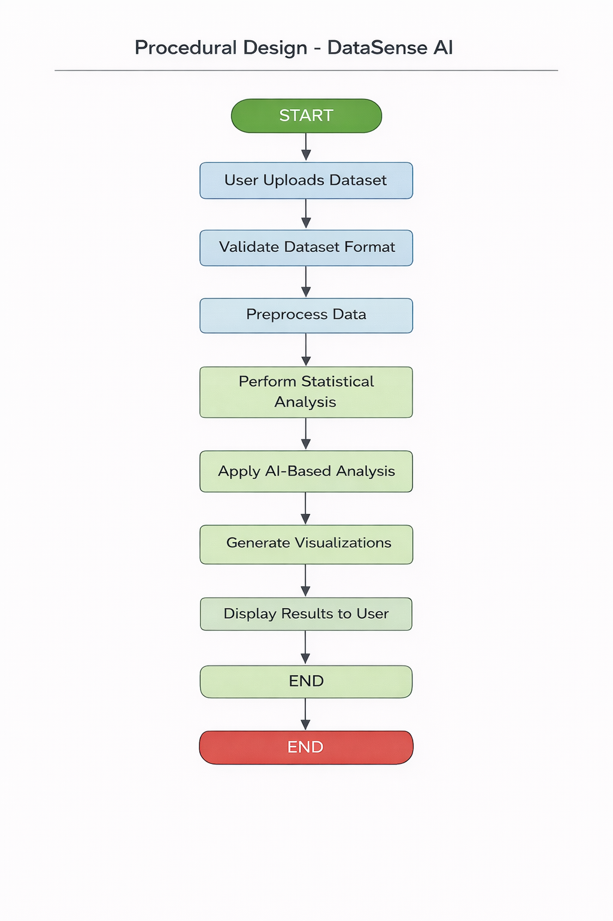

1. Home Page / Dashboard
The home page acts as the main entry point of the system. It provides an overview of the application and guides the user toward dataset upload and analysis features. Summary information such as dataset status and available analysis options is displayed on this screen.

2. Dataset Upload Interface
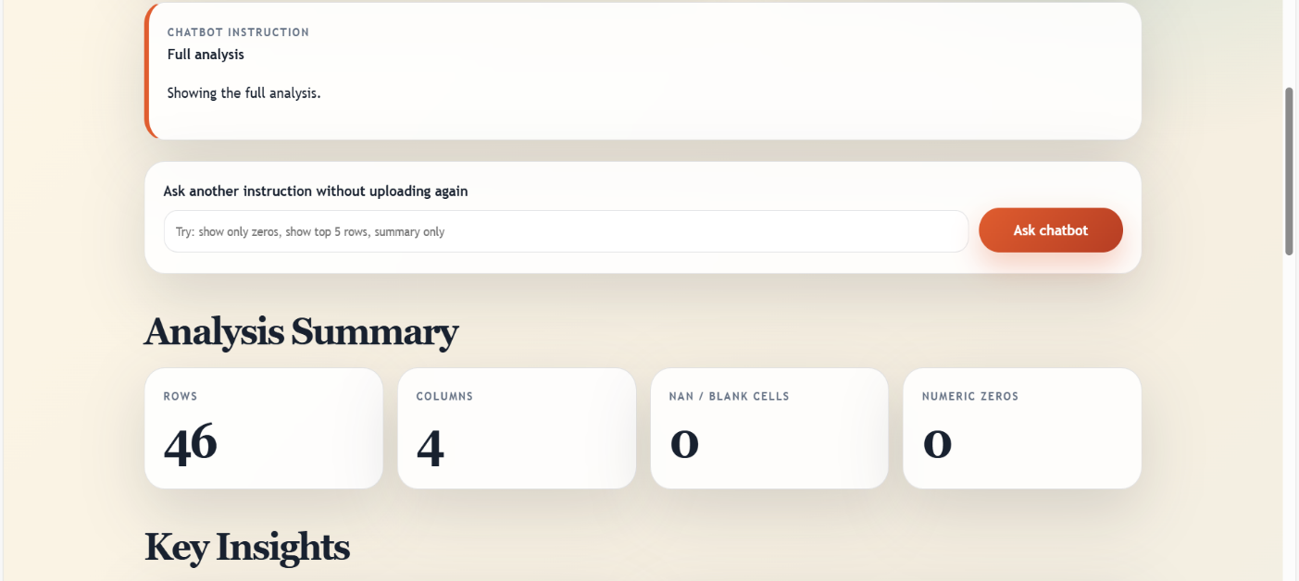
This interface allows users to upload datasets in CSV or Excel format. The system validates the uploaded file and displays appropriate success or error messages. This screen ensures that only supported and valid datasets are processed.

3. Data Preprocessing View
After uploading the dataset, the preprocessing interface displays information about missing values, duplicate records, and data normalization. This screen helps users understand how raw data is cleaned before analysis.

4. Statistical Analysis Screen
This screen presents computed statistical measures such as mean, median, standard deviation, minimum, and maximum values in a tabular format. It enables users to understand the basic characteristics of the dataset.
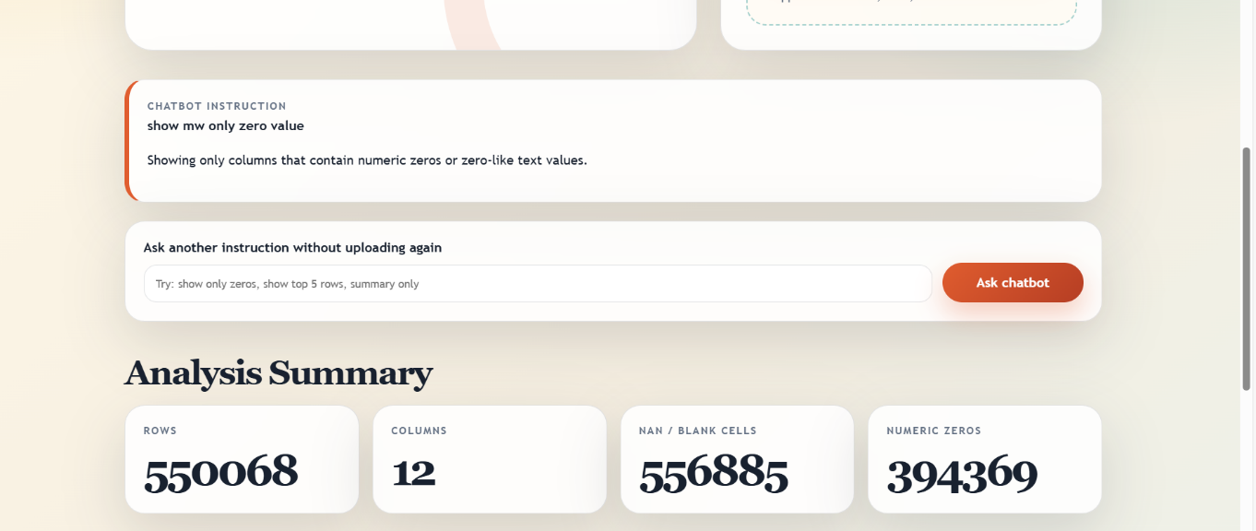

5. Visualization Interface
The visualization screen displays graphical representations such as bar charts, histograms, and correlation heatmaps. These graphs help users identify trends, patterns, and relationships within the dataset.
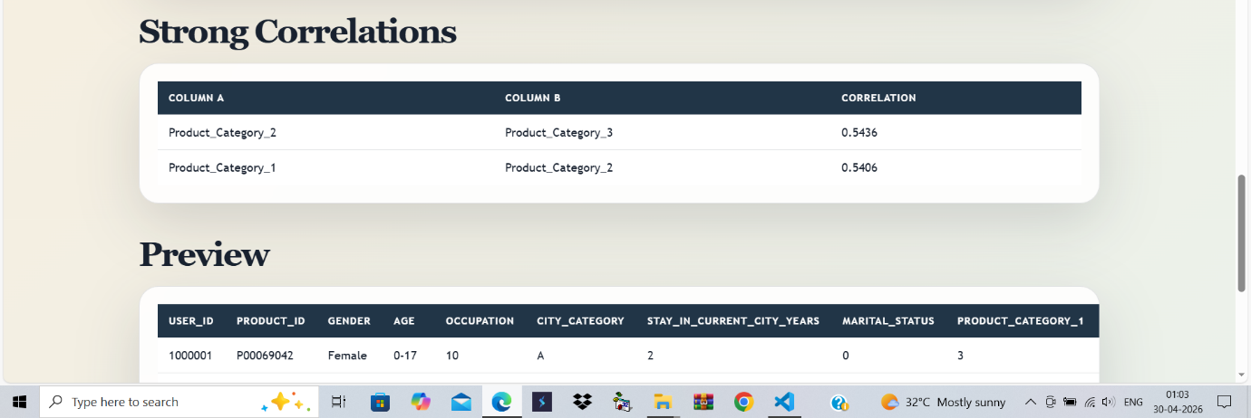

6. Outlier Detection Screen
This interface highlights abnormal data points detected using AI-based techniques. The screen provides clear indications of outliers, helping users identify data inconsistencies.

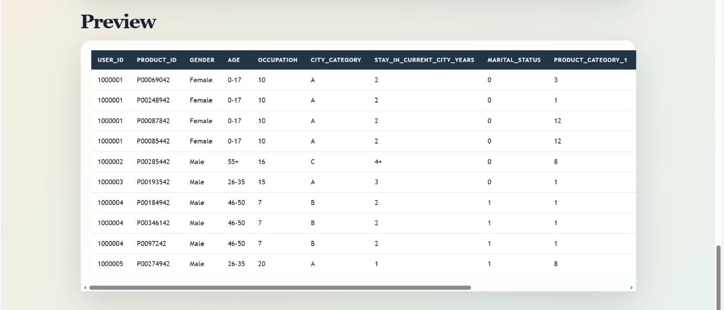

Chapter 6 :Coding Standard Followed and Assumptions
#about.html
{% extends 'index.html' %}
{% block content %}
<div class="about-page">
<h1>About DataSense AI</h1>
<p><strong>DataSense AI</strong> is a professional, AI-powered data analysis and visualiza</p>
<h2>Our Mission</h2>
<p>To democratize data analysis by providing a powerful, user-friendly tool that turns ra</p>
</div>
{% endblock %}
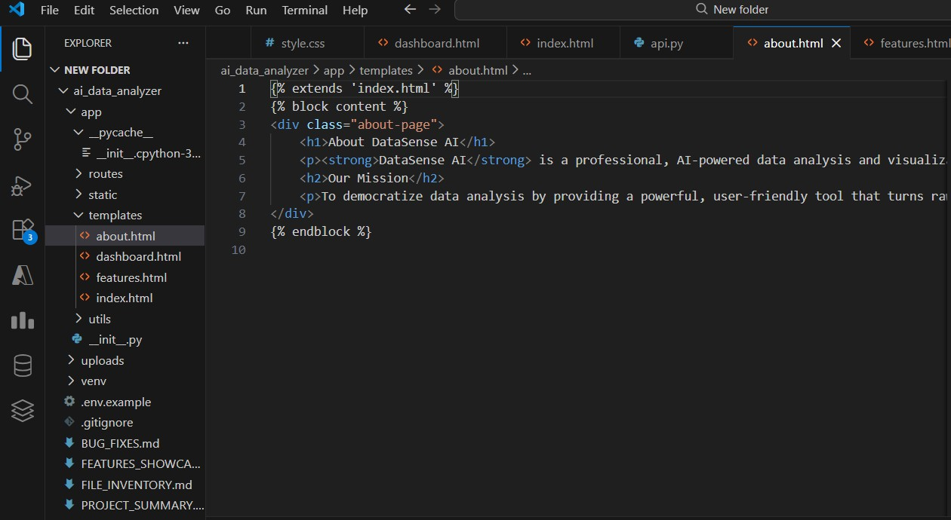

#requirements.txt
Flask==2.3.3
Flask-CORS==4.0.0
pandas==2.1.1
numpy==1.24.3
openpyxl==3.1.2
PyPDF2==3.0.1
python-dotenv==1.0.0
scikit-learn==1.3.1
plotly==5.17.0
Werkzeug==2.3.7
requests==2.3.10
google-generativeai==0.3.0
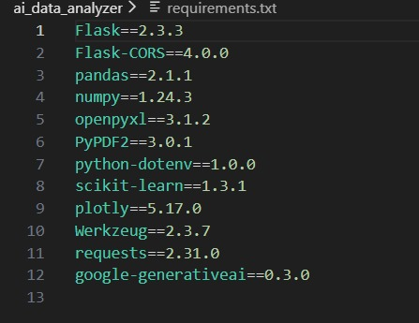

File Name: BlackFriday_Sales.csv
Start View (Line 1): User_ID,Product_ID,Gender,Age,Occupation,City_Category,Stay_In_Current_City_Years,Marital_S...

End View (Line 32): 1000010,P00118742,F,36-45,1,B,4+,1,5,11,,8886
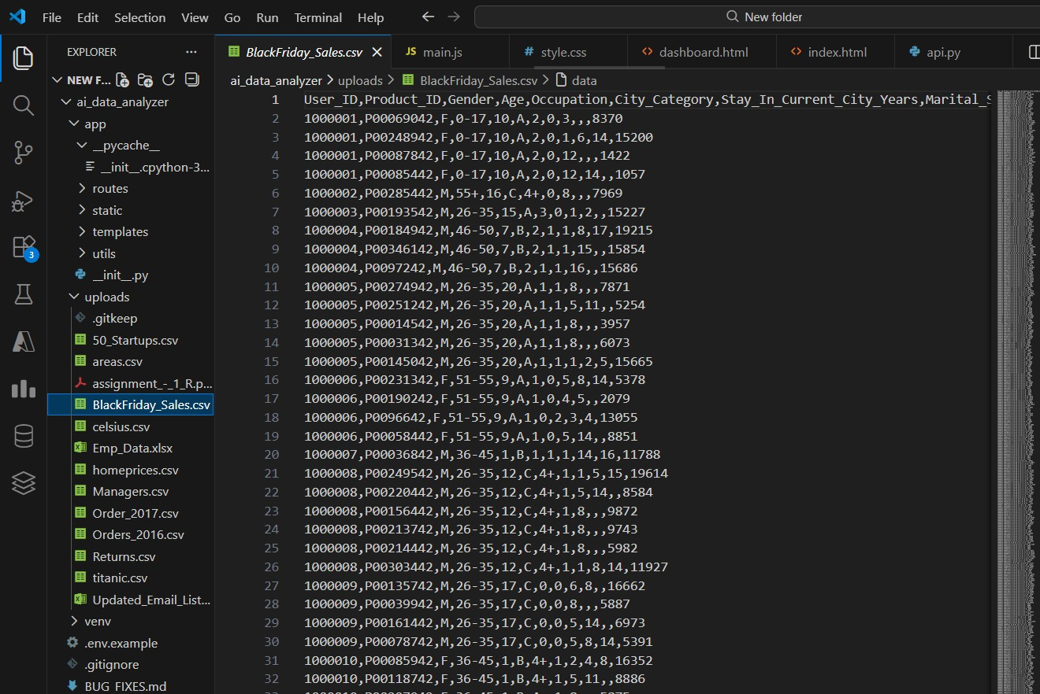

#run.py
import os
from app import create_app

if _name_ == '_main_':
app = create_app()

# Run the Flask application
debug_mode = os.getenv('FLASK_DEBUG', 'False') == 'True'

app.run(
host='0.0.0.0',
port=5000,
debug=debug_mode
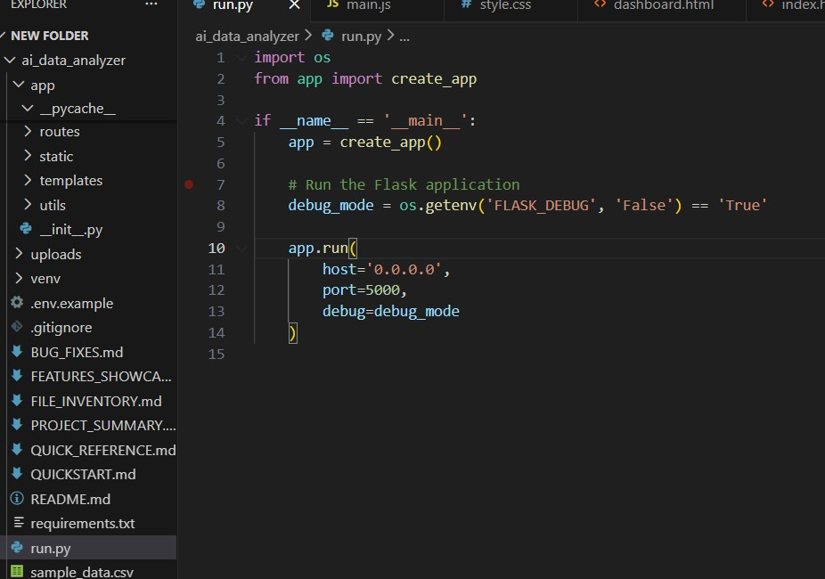
)

#features.html

{% extends 'index.html' %}
{% block content %}
<div class="features-page">
<h1>Features</h1>
<ul>
<li>AI-powered data cleaning and auto-fixing for messy CSVs</li>
<li>Instant summary statistics and missing value analysis</li>
<li>Interactive visualizations: Histogram, Box Plot, Scatter Plot, Bar Chart, Pie Chart</li>
<li>Supports CSV, Excel, PDF, and TXT uploads</li>
<li>Handles large files (up to 500MB)</li>
<li>Tabbed interface for Overview, Analysis, Visualizations, and Data Preview</li>
<li>Custom chart creation with smart column selection</li>
<li>Modern, responsive UI</li>
</ul>
</div>
{% endblock %}

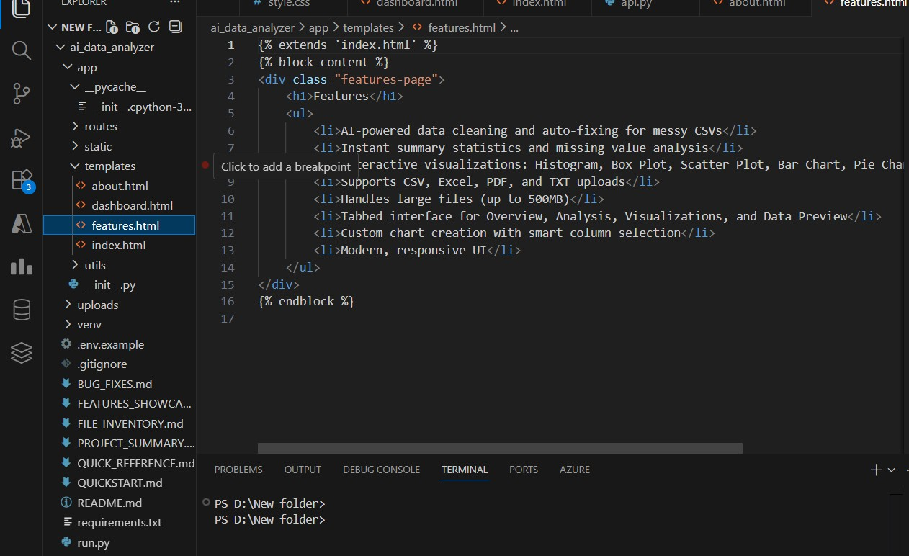

2nd Html page code:

#index.html

<html lang="en">
<head>
<script src="https://cdn.plot.ly/plotly-latest.min.js"></script>
</head>
<body>
<nav class="navbar">
<div class="navbar-container">
<div class="logo">
<span class="logo-icon">📊</span>
<span class="logo-text">DataSense AI</span>
</div>
<div class="nav-links">
<a href="/" class="nav-link active">Analyzer</a>
<a href="/features" class="nav-link">Features</a>
<a href="/about" class="nav-link">About</a>
</div>
</div>
</nav>

<div class="container">
<section class="upload-section">
<div class="upload-container">
</div>
</section>
</div>
</body>
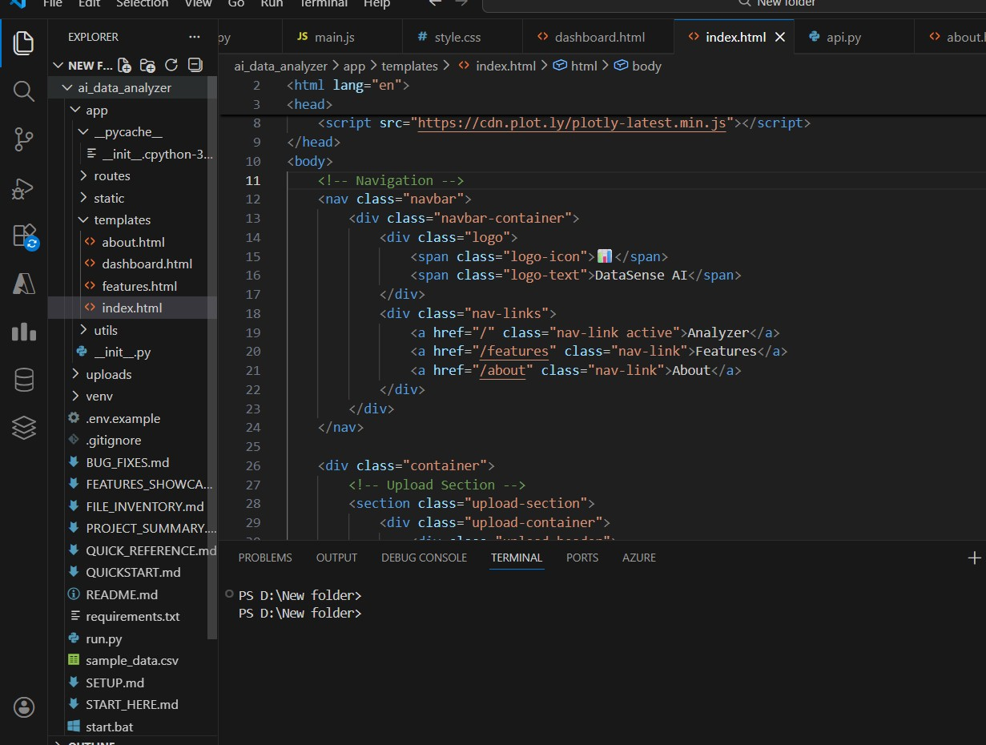
</html>

#dashboard.html

<!DOCTYPE html>
<html lang="en">
<head>
<meta charset="UTF-8">
<meta name="viewport" content="width=device-width, initial-scale=1.0">
<title>Dashboard - AI Data Analyzer</title>
<link rel="stylesheet" href="{{ url_for('static', filename='css/style.css') }}">
</head>
<body>
<nav class="navbar">
<div class="navbar-container">
<div class="logo">
<span class="logo-icon">📊</span>
<span class="logo-text">DataSense AI</span>
</div>
<div class="nav-links">
<a href="/" class="nav-link">Back to Analyzer</a>
</div>
</div>
</nav>

<div class="container">
<div class="dashboard-placeholder">
<h1>Dashboard Coming Soon</h1>
<p>Advanced analytics and reporting features will be available here.</p>
<a href="/" class="btn-primary">Go to Analyzer</a>
</div>
</div>

<script src="{{ url_for('static', filename='js/main.js') }}"></script>
</body>
</html>
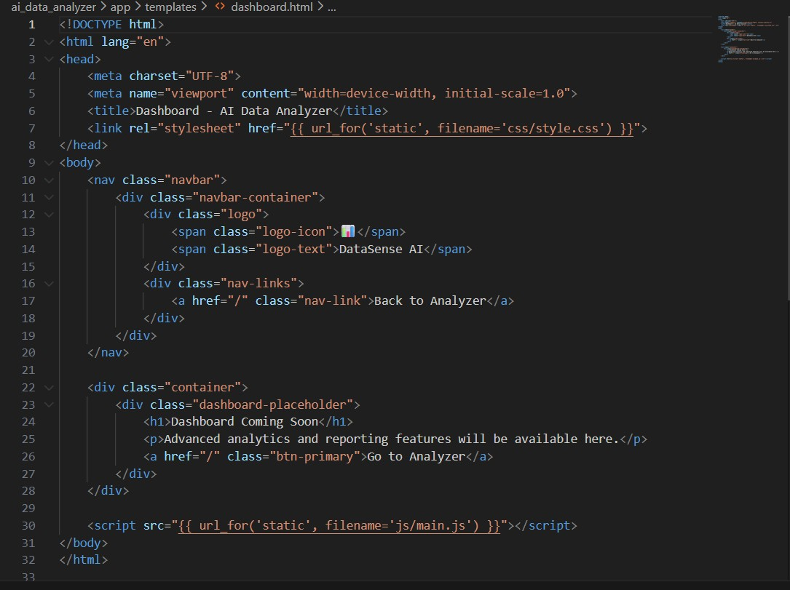

#app.py
from flask import Flask, render_template, request
import pandas as pd
import os
import matplotlib.pyplot as plt

app = Flask(__name__)
UPLOAD_FOLDER = 'static/uploads'
app.config['UPLOAD_FOLDER'] = UPLOAD_FOLDER

@app.route('/')
def index():
return render_template('index.html')
@app.route('/analyze', methods=['POST'])
def analyze():
file = request.files['dataset']
filepath = os.path.join(app.config['UPLOAD_FOLDER'], file.filename)
file.save(filepath)

df = pd.read_csv(filepath)

stats = df.describe().to_html()

numeric_cols = df.select_dtypes(include='number').columns
graph_path = None

if len(numeric_cols) > 0:
plt.figure()
df[numeric_cols[0]].hist()
graph_path = 'static/uploads/graph.png'
plt.savefig(graph_path)
plt.close()

return render_template(
'result.html',
tables=stats,
graph=graph_path
)

if __name__ == '__main__':
app.run(debug=True)

index.html
<!DOCTYPE html>
<html>
<head>
<title>DataSense AI</title>
</head>
<body>
<h2>DataSense AI - Dataset Upload</h2>

<form action="/analyze" method="post" enctype="multipart/form-data">
<input type="file" name="dataset" required>
<br><br>
<button type="submit">Analyze Data</button>
</form>
</body>
</html>

result.html
<!DOCTYPE html>
<html>
<head>
<title>Analysis Result</title>
</head>
<body>
<h2>Statistical Analysis</h2>
{{ tables|safe }}
{% if graph %}
<h2>Data Visualization</h2>
<img src="/{{ graph }}" width="500">
{% endif %}

<br><br>
<a href="/">Go Back</a>
</body>
</html>

requirements.txt
- flask
- pandas
- matplotlib

RESULT SET ANALYSIS :

Introduction
Result set analysis refers to the systematic examination and interpretation of outputs generated by the DataSense AI system after processing the input dataset. The purpose of this analysis is to evaluate the effectiveness of the system in extracting meaningful information from raw data. The result set includes statistical summaries, graphical visualizations, and detected anomalies, which together provide a comprehensive understanding of the dataset.

Dataset Description
For experimental evaluation, the DataSense AI system was tested using structured datasets in CSV format. One of the primary datasets used was a sales dataset containing attributes such as customer demographics, product categories, and transaction values. The dataset consisted of both numerical and categorical variables, making it suitable for statistical analysis and visualization.
Before analysis, the dataset was validated and cleaned to remove inconsistencies such as missing values and duplicate records. This preprocessing step ensured that the result set generated by the system was accurate and reliable.

Statistical Result Analysis
The system automatically computed descriptive statistical measures including mean, median, standard deviation, minimum, and maximum values for numerical attributes. These measures helped identify central tendencies and variability within the data.
For example, the mean and median values indicated the overall trend of the dataset, while the standard deviation highlighted the dispersion of data points. The comparison of these values enabled users to understand whether the dataset followed a normal distribution or contained skewed values.

Graphical Result Analysis
DataSense AI generated multiple graphical outputs to visually represent the dataset. Histograms were used to analyze data distribution, while bar charts illustrated category-wise comparisons. Correlation heatmaps provided insights into relationships between numerical variables.
These graphical representations simplified complex data patterns and made it easier to identify trends, seasonal variations, and anomalies. Visualization proved especially useful for non-technical users, as it transformed raw numerical data into interpretable visual insights.

Outlier Detection Analysis
The system applied statistical techniques to identify outliers within the dataset. Outliers are data points that significantly deviate from the normal range and may indicate errors, unusual events, or valuable insights.
The result set highlighted these outliers, allowing users to decide whether to remove them or further investigate their causes. The ability to detect outliers improved data quality and enhanced the reliability of analytical outcomes.

Performance Evaluation
The system demonstrated efficient performance by processing large datasets within a short time frame. Automated analysis reduced manual effort and minimized human error. The response time remained consistent even with increasing dataset size, indicating good scalability for academic and small-scale business applications.

Result Interpretation
The result set generated by DataSense AI provided actionable insights that could support informed decision-making. Statistical summaries offered quantitative understanding, while visualizations enabled intuitive interpretation. The integration of these outputs validated the effectiveness of the proposed system.

Conclusion of Result Set Analysis
The result set analysis confirms that DataSense AI successfully meets its objectives of automating data analysis and delivering meaningful insights. The system effectively processes structured datasets, generates accurate statistical results, and presents them through intuitive visualizations. Overall, the result set demonstrates the practical applicability and reliability of DataSense AI as an AI-powered analytics platform suitable for final-year academic projects.
I am share a graphical structure :
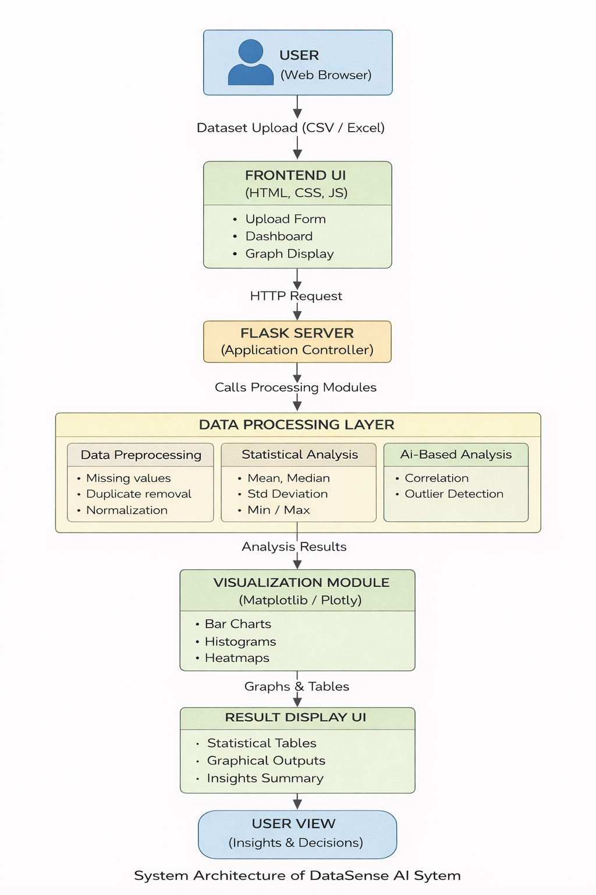

SOFTWARE TESTING :

Introduction to Testing
Software testing is a critical phase in the development of DataSense AI, as it ensures that the system functions correctly, efficiently, and reliably. The primary goal of testing in this project is to validate that each module performs according to the specified requirements and that the overall system produces accurate analytical results. Testing also helps in identifying errors, improving system quality, and ensuring user satisfaction.
In DataSense AI, testing was carried out at different levels, starting from individual modules to the complete integrated system.

Testing Strategy Used
The testing strategy adopted for DataSense AI follows a structured approach. Initially, individual components such as dataset upload, preprocessing, and analysis modules were tested independently. After successful verification of individual modules, integration testing was performed to ensure smooth interaction between frontend, backend, and data processing layers. Finally, system-level testing was conducted to validate the complete workflow from dataset upload to result visualization.

Types of Testing Performed
Unit Testing
Unit testing focuses on verifying the functionality of individual modules of the system. In DataSense AI, unit testing was performed on data preprocessing functions, statistical calculation functions, and visualization generation methods. Each function was tested using sample datasets to ensure correct outputs.
For example, the preprocessing module was tested to confirm that missing values and duplicate records were handled correctly. The statistical analysis module was tested to verify accurate calculation of mean, median, and standard deviation.

Integration Testing
Integration testing ensures that different modules of the system work together seamlessly. In this project, integration testing validated the interaction between the frontend interface and the Flask backend, as well as the communication between backend logic and data processing libraries such as Pandas and Matplotlib.
During this phase, the system was tested by uploading datasets through the user interface and verifying that the backend correctly processed the data and returned the results to the frontend without errors.

System Testing
System testing evaluates the complete DataSense AI application as a whole. This testing confirmed that the system meets all functional requirements. The entire workflow—from dataset upload to result visualization—was tested using real-world datasets.
System testing verified that the application handles different dataset sizes, generates correct graphs, and displays analytical results properly on the user interface.

User Acceptance Testing (UAT)
User Acceptance Testing was performed to ensure that the system is user-friendly and meets user expectations. Students and non-technical users tested the application by uploading datasets and interacting with the analysis features. Feedback confirmed that the interface was easy to use and the results were easy to understand.

Test Case Analysis:

Test Case 1: Dataset Upload
Input: CSV file
Expected Result: File uploaded successfully
Actual Result: Dataset uploaded and validated correctly
Status: Pass
Test Case 2: Statistical Analysis
Input: Numerical dataset
Expected Result: Correct calculation of statistical values
Actual Result: Accurate statistics displayed
Status: Pass
Test Case 3: Graph Generation
Input: Dataset with numerical columns
Expected Result: Graph generated without error
Actual Result: Histogram displayed correctly
Status: Pass
Test Case 4: Invalid File Upload
Input: Unsupported file format
Expected Result: Error message displayed
Actual Result: Validation error shown
Status: Pass

Performance Testing
Performance testing was conducted to evaluate the response time and efficiency of the system. The application was tested using datasets of varying sizes. The results showed that DataSense AI handled moderate-sized datasets efficiently with minimal processing delay, making it suitable for academic and small-scale analytical applications.

Security and Reliability Testing
Basic security checks were performed to ensure safe file uploads and prevent unsupported file execution. The system stores uploaded files temporarily and does not retain user data permanently, ensuring data privacy and reliability.

Testing Results Summary
The testing process confirmed that DataSense AI performs reliably and accurately. All functional modules worked as expected, and no major defects were observed during testing. The system met all project objectives and demonstrated stable performance.

Running this whole process steps:
Step 1: Run the Application
python app.py
Step 2: Upload Different Datasets
- Valid CSV file → Check successful analysis
- Large dataset → Observe performance
- Invalid file → Check error handling
Step 3: Observe Outputs
- Statistical tables
- Generated graphs
- Page navigation
Step 4: Verify Console Logs
- Flask console confirms requests and processing

TEST CASE TABLE – DATASENSE AI :
Test Case ID | Test Case Description | Input Data | Expected Result | Actual Result | Status
TC-01 | Verify application launch | Run Flask server | Application homepage should load successfully | Homepage displayed correctly | Pass
TC-02 | Verify dataset upload | Valid CSV file | Dataset should upload without error | Dataset uploaded successfully | Pass
TC-03 | Validate file format | Invalid file (.txt/.pdf) | System should reject file and show error message | Error message displayed | Pass
TC-04 | Check data preprocessing | Dataset with missing values | Missing values should be handled automatically | Missing values processed correctly | Pass
TC-05 | Verify statistical analysis | Numerical dataset | Mean, median, std deviation should be calculated | Correct statistical values shown | Pass
TC-06 | Verify graph generation | Dataset with numeric columns | Histogram/bar chart should be generated | Graph displayed correctly | Pass
TC-07 | Check outlier detection | Dataset with extreme values | Outliers should be identified | Outliers detected correctly | Pass
TC-08 | Verify result display | Analyzed dataset | Results should be displayed on result page | Results displayed properly | Pass
TC-09 | Performance testing | Large dataset | System should respond within acceptable time | Response time acceptable | Pass
TC-10 | User navigation test | Back/refresh actions | Navigation should work without errors | Navigation working correctly | Pass
TC-11 | Security validation | File upload attempt with script | System should prevent unsafe execution | Unsafe file blocked | Pass
TC-12 | User acceptance test | Real user interaction | System should be user-friendly | Positive user feedback | Pass

Future Scope
The Data Sense AI project opens up several avenues for future development and enhancement:
- Real-Time Data Analytics: Currently, the system processes pre-existing datasets. In the future, it can be upgraded to handle real-time streaming data, enabling instant insights and faster decision-making.
- Integration with IoT Devices: By connecting with IoT sensors and smart devices, DataSense AI can analyze live environmental, industrial, or consumer data, expanding its applications in smart cities, healthcare, and manufacturing.
- Enhanced Predictive Capabilities: Incorporating advanced machine learning models like deep learning and reinforcement learning can improve the accuracy of predictions and pattern recognition in complex datasets.
- Scalability and Big Data Handling: With the integration of cloud computing and big data frameworks (e.g., Apache Spark, Hadoop), the system can manage larger datasets efficiently, making it suitable for enterprise-level analytics.
- Natural Language Processing (NLP) Expansion: Future versions can process unstructured text from social media, reports, and documents, providing sentiment analysis, trend detection, and automated summarization.
- User-Friendly Dashboards and Visualization: Enhanced visualization tools and interactive dashboards can help non-technical users interpret data insights more easily, increasing accessibility and usability.
- Industry-Specific Applications: The system can be customized for specific industries such as finance, healthcare, retail, and logistics, providing specialized insights tailored to domain requirements.
- AI-Driven Recommendations: Beyond analysis, the system can evolve to provide actionable recommendations, supporting decision-making processes in real-time scenarios.
Overall, the future scope of DataSense AI is vast, and with continuous advancements in AI and data science, it can evolve into a highly intelligent platform capable of delivering smarter, faster, and more comprehensive data-driven solutions.

Future Goals (Market needs based)
- Real-Time Decision Support: Develop the system to process live data streams and provide immediate insights for faster and more accurate decision-making.
- Advanced AI Integration: Implement deep learning and reinforcement learning models to enhance predictive capabilities and handle more complex datasets.
- Scalable Architecture: Expand the platform using cloud computing and big data frameworks to manage enterprise-level data efficiently.
- Cross-Industry Applications: Customize DataSense AI for various industries like healthcare, finance, logistics, and retail, enabling domain-specific insights.
- Enhanced User Experience: Build interactive dashboards and visualization tools to make insights easily accessible for non-technical users.
- Automated Recommendations: Incorporate AI algorithms to provide actionable suggestions, helping organizations make smarter, data-driven decisions.
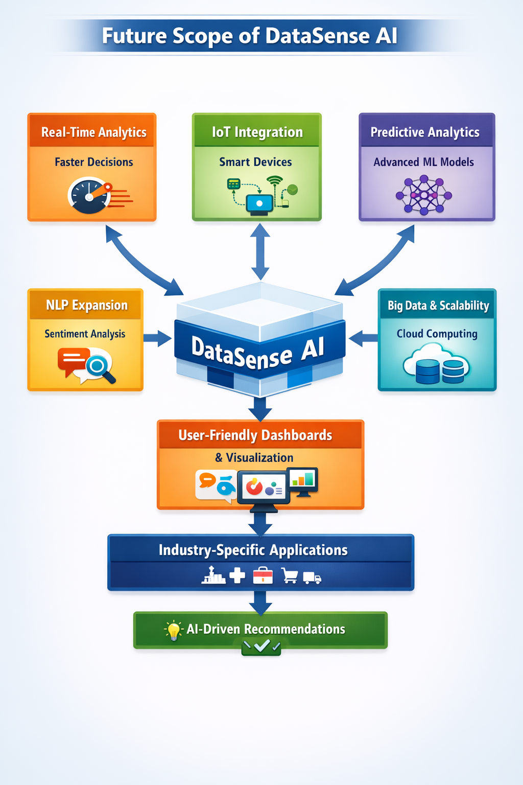
Conclusion :
The DataSense AI project demonstrates the significant potential of artificial intelligence in transforming raw and unstructured data into meaningful insights. By leveraging AI algorithms, the system efficiently analyzes large datasets, identifies patterns, and provides predictive and actionable intelligence, which is invaluable for informed decision-making. This project highlights the advantages of automation in data processing, reducing human effort, minimizing errors, and accelerating analysis.
The implementation of DataSense AI proves that combining machine learning techniques with advanced data analytics can lead to smarter, faster, and more accurate interpretations of data. Overall, this project not only showcases technical proficiency in AI and data handling but also underlines the practical applicability of AI-driven analytics across industries. The results obtained validate the system’s effectiveness and pave the way for future enhancements, including integration with real-time data streams and expansion to broader datasets.

